Light Operated Film Marker

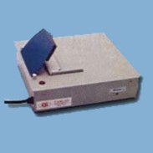

The film marker is used to transfer information that has been written or typed on a piece of paper to an industrial or medical X-ray film. The housing contains a light source and electronic regulator assembly. The top plate of the housing acts as a film stage. Towards the rear of the film stage there is an aperture covered by opal glass. The light source is located directly below the aperture. Above the aperture is a hinged flap, lined with foam rubber. When the flap is pressed down, the light source illuminates for a predetermined length of time.

